Time Zone

Definition:
# Source: AI Source: Provided by: [Data Path: Persons Table -> ID Column: 1, Name_En Column: Motasem Essam] -> From: [ChatGPT] on [1/26/2026]
A time zone is a region of the Earth that has the same standard time. Time zones are usually defined as offsets from Coordinated Universal Time (UTC).

In timekeeping, “offsets from Coordinated Universal Time (UTC)” means:
How many hours (and minutes) a local time is ahead of or behind UTC.

Key Points
# Source: AI Source: Provided by: [Data Path: Persons Table -> ID Column: 1, Name_En Column: Motasem Essam] -> From: [ChatGPT] on [1/26/2026]
- Offset from UTC: Each time zone is expressed as UTC±X hours.
  - Example: UTC+5:30 → India Standard Time (IST)
  - UTC-8 → Pacific Standard Time (PST)
- Daylight Saving Time (DST): Some time zones adjust clocks forward or backward during certain months.
- Purpose: Time zones exist because the Earth rotates 360° in 24 hours, so local time differs by longitude.
- Global Coordination: Time zones help coordinate activities, travel, and communication worldwide.

Example of Time Zones
# Source: AI Source: Provided by: [Data Path: Persons Table -> ID Column: 1, Name_En Column: Motasem Essam] -> From: [ChatGPT] on [1/26/2026]
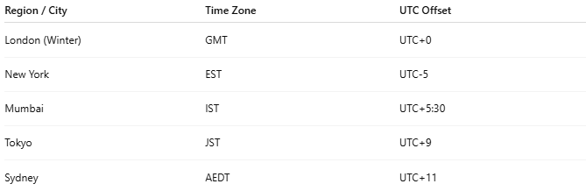
Region / City | Time Zone | UTC Offset
London (Winter) | GMT | UTC+0
New York | EST | UTC-5
Mumbai | IST | UTC+5:30
Tokyo | JST | UTC+9
Sydney | AEDT | UTC+11

How Time Zones Work
# Source: AI Source: Provided by: [Data Path: Persons Table -> ID Column: 1, Name_En Column: Motasem Essam] -> From: [ChatGPT] on [1/26/2026]
- Earth is divided into 24 time zones, roughly 15° of longitude each.
- When it’s 12:00 PM UTC, it is:
  - 5:30 PM in India (UTC+5:30)
  - 7:00 AM in New York (UTC-5)

Analogy
# Source: AI Source: Provided by: [Data Path: Persons Table -> ID Column: 1, Name_En Column: Motasem Essam] -> From: [ChatGPT] on [1/26/2026]
- UTC → Master clock
- Time zone → Local clock set according to the master clock, adjusted for local position on Earth

Usage
# Source: AI Source: Provided by: [Data Path: Persons Table -> ID Column: 1, Name_En Column: Motasem Essam] -> From: [ChatGPT] on [1/26/2026]
- Scheduling international meetings
- Setting clocks in computers, smartphones, and servers
- Aviation, shipping, and communication rely on time zones for coordination

✅ Summary
# Source: AI Source: Provided by: [Data Path: Persons Table -> ID Column: 1, Name_En Column: Motasem Essam] -> From: [ChatGPT] on [1/26/2026]
- Time zone = region sharing the same standard time
- Defined as offset from UTC
- Helps coordinate time across the world

